Train Managers to Adopt an Informed Trust Approach Executive Briefing

Summary
Employee engagement efforts have stagnated over the past ten years. Annual surveys and action planning have failed to move the needle. At the same time, trust in leadership has faltered; primarily driven by widespread downsizing and public corruption scandals.

Our Recommendation
- Training on informed trust will help leaders accurately assess the trust environment and apply appropriate trust techniques. Training components include:
  - Practical application of the informed trust model to increase employee empowerment.
  - A comprehensive overview of each component of the informed trust model: Assess, Give, and Verify.

Client Challenge

Trust drives engagement through employee empowerment. However, leaders are sometimes reluctant to give trust to employees.

Critical Insight

Trust is a willingness to give up control due to a belief in the creation of a particular outcome, with consideration given to risk. This requires moving from paternalism to partnership. To put trust into action requires an informed approach to minimize the inherent risk in trusting others.

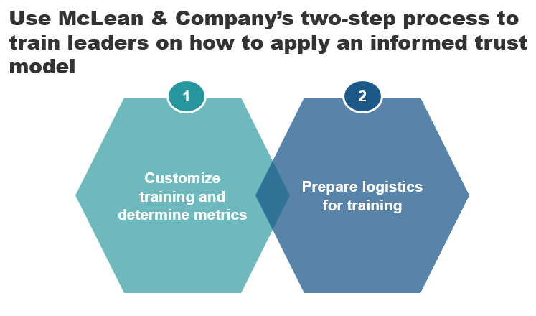

Get to Action
1. Customize training and determine metrics | - Understand the informed trust training content.  - Customize the training content.  - Determine metrics for training.  Deliverables:  - Case Studies: Train Managers to Adopt an Informed Trust Approach  - Training Deck: Use an Informed Trust Approach to Drive Employee Engagement and Business Results  - Informed Trust Participant Handbook  - Informed Trust Leader Self-Assessment  - Informed Trust Quiz  - Informed Trust Training Session Feedback Template  - Informed Trust Individual Development Plan
2. Prepare logistics for training | - Establish training logistics.  - Prepare a communication plan.

__________________________________________________

For acceptable use of this template, refer to McLean & Company's Terms of Use. These documents are intended to supply general information only, not specific professional, personal, legal, or accounting advice, and are not intended to be used as a substitute for any kind of professional advice. Use this document either in whole or in part as a basis and guide for document creation. To customize this document with corporate marks and titles, simply replace the McLean & Company information in the Header and Footer fields of this document.

