Create a People-First Diversity, Equity, and Inclusion Strategy Executive Briefing

Summary
Most organizations recognize that there are several benefits that come from being inclusive to diverse groups of employees. However, despite the implementation of numerous diversity, equity, and inclusion (DEI) initiatives, organizations are still having trouble making progress.

Our Recommendation
- Organizations must create a DEI strategy that is based on their specific organizational DEI challenges. Assess the current state of DEI through organizational data and focus groups, not based on current trends and fads in DEI training.
- With a DEI strategy project team, identify a clear purpose for DEI that is upheld by defined strategic pillars, carried out by specific DEI initiatives (e.g. inclusive leadership behavior training, implementing sponsorship programs, expanding campus recruitment strategies to more diverse schools), and overseen by a governance model.
- Implement DEI across the organization with initiatives that support all parts of the employee lifecycle.

Client Challenge
- DEI is complex and heavily nuanced. This means that every DEI strategy needs to be based on the specific DEI challenges the organization faces.
- DEI is often siloed under HR, but everyone has a role to play as allies, leaders, and champions when it comes to creating an organization that has diverse groups of employees and is equitable and inclusive. However, it is not always clear how everyone participates in creating a diverse and inclusive organization.

Critical Insight
- Diversity, equity, and inclusion is a continuum – an ongoing journey of unlearning and learning the deeply rooted dogmas that guide the way organizations operate.
- The DEI strategy is a mechanism through which systemic issues and the ingrained way things are done at organizations can be challenged and changed.
- Creating a scaled and purposeful strategy, upheld by strategic pillars and customized DEI initiatives, kick-starts the journey.
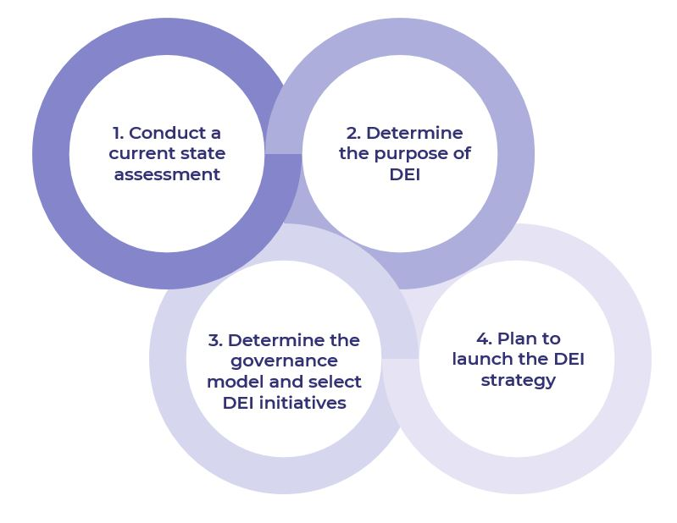

Get to Action
1. Conduct a current state assessment | - Create a DEI strategy project team.  - Gather organizational data to uncover DEI gaps and challenges.  - Conduct focus groups to uncover the employee experience.  - Review the organization’s broader strategic goals and priorities.  - Gather external data to understand the broader DEI landscape.  - Complete the DEI diagnostic.  Deliverables:  - Diversity, Equity, and Inclusion Primer  - Diversity, Equity, and Inclusion Workbook  - Biases & Heuristics Catalog  - Standard Focus Group Guide  - Diversity, Equity, and Inclusion Assessment
2. Determine the purpose of DEI | - Conduct a SWOT analysis.  - Define the overarching purpose for DEI.  - Determine strategic pillars.  - Identify goals and metrics.  Deliverables:  - Standard SWOT Analysis Template  - Diversity, Equity, and Inclusion Workbook  - HR Metrics Library
3. Determine the governance model and select DEI initiatives | - Clarify roles and accountabilities for each component of the governance model.  - Examine the employee lifecycle from a DEI lens.  - Select and customize DEI initiatives to implement.  Deliverables:  - Diversity, Equity, and Inclusion Workbook  - Diversity, Equity, and Inclusion Initiatives Catalog  - Job-Aid: Diversity, Equity, and Inclusion in Talent Acquisition
4. Plan to launch the DEI strategy | - Identify clear DEI responsibilities across the organization.  - Develop a clear action plan for launching the DEI strategy.  - Embed the DEI strategy in the organizational EVP and brand.  - Determine a communication plan for the DEI strategy.  Deliverables:  - Diversity, Equity, and Inclusion Workbook  - Standard Internal Communications Plan  - Training Deck: Equip Managers to Adopt Inclusive Leadership Behaviors  - Handbook: Equip Managers to Adopt Inclusive Leadership Behaviors  - Role Play Scenarios: Equip Managers to Adopt Inclusive Leadership Behaviors  - Standard Participant Training Session Evaluation Template  - Diversity, Equity, and Inclusion Strategy Presentation Template

__________________________________________________

For acceptable use of this template, refer to McLean & Company's Terms of Use. These documents are intended to supply general information only, not specific professional, personal, legal, or accounting advice, and are not intended to be used as a substitute for any kind of professional advice. Use this document either in whole or in part as a basis and guide for document creation. To customize this document with corporate marks and titles, simply replace the McLean & Company information in the Header and Footer fields of this document.

