Develop an Impactful High-Potential Program Executive Briefing

Summary
High-potential (hi-po) employees deliver key results to organizations and hi-po programs help to retain these valuable employees. However, these benefits are often not realized as many organizations fail to formalize and customize hi-po programs for their organizational needs. Organizations often struggle to define potential. In fact, many organizations confuse high performance with high potential.

Our Recommendation
- Develop a formalized program that realizes the full benefits of high-potential employees.
- Ensure the program delivers its purpose by defining high-potential as it relates to the organization, identifying assessment methods that successfully assess for that definition, creating a development framework that helps hi-po employees achieve their potential, and regularly evaluating and iterating the program to align with the needs of the organization.
- Keep diversity, equity, and inclusion at the forefront of the hi-po program to intentionally develop a diverse pipeline of future leaders for the organization.

Client Challenge
- The lack of a clear definition leads to difficulties in effectively assessing for hi-pos and risks amplifying inequities.
- Organizations fail to leverage different training methods, leading to the ineffective development of hi-po employees.
- Furthermore, organizations miss the opportunity to use hi-po programs to support the growth of diverse talent.

Critical Insight
- The success of a hi-po program is based on the sum, not one individual part – they all work together to create the program. Purposefully design a hi-po program that consistently identifies and develops the right people, helping achieve their aspirations and organizational goals from start to finish.
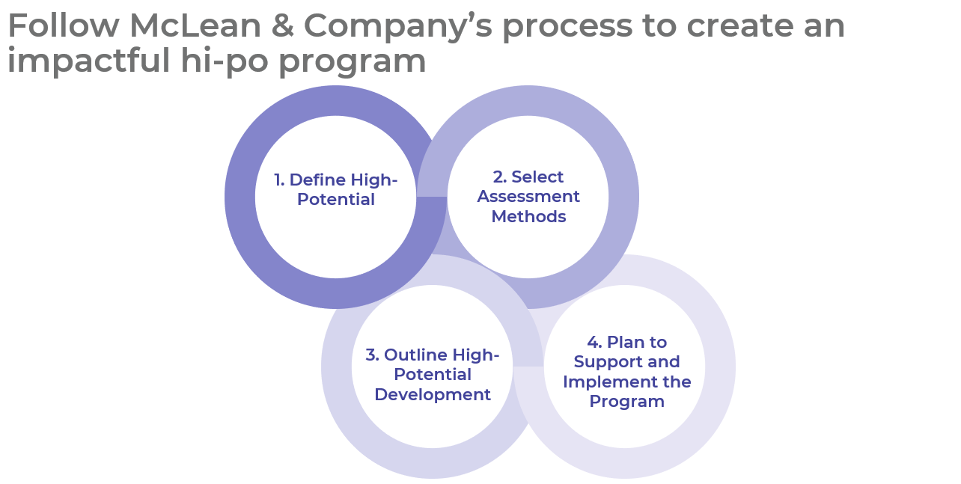

Get to Action
1. Define High-Potential | - Outline the need for the hi-po program and any program constraints.  - Define high-potential and participant outcomes.  - Determine program transparency level.  - Set program goals and metrics.  Deliverables:  - High-Potential Program Workbook  - Standard Focus Group Guide  - People Manager Conversation Template: Unsuccessful High-Potential Candidates  - HR Metrics Library  - Case Studies: Develop an Impactful High-Potential Program
2. Select Assessment Methods | - Determine the scope of selection assessments.  - Outline how many employees will be selected and the cadence for their selection.  - Determine the scope of development assessments.  - Review and select assessments for selection and development.  Deliverables:  - Self-Nomination Template  - High-Potential Assessment Catalog  - 9-Box Job Aid  - 9-Box Talent Grid Assessment  - Alternate 9-Box Talent Grid Assessment  - Individual Talent Profile Template
3. Outline High-Potential Development | - Plan to interpret development assessment results.  - Select a program format, time approach, and the duration of hi-po development.  - Review learning methods and define stakeholder responsibilities for development.  - Determine next steps for hi-pos once the program concludes.  Deliverables:  - Learning Methods Catalog  - Individual Development Plan Template
4. Plan to support and implement the program | - Align the hi-po program with other HR programs.  - Decide on a roll-out method.  - Summarize the hi-po program for stakeholders.  - Communicate the program internally.  - Develop and provide training on program implementation.  - Conduct a post-mortem of the program and create a plan to evaluate and iterate the program on an ongoing basis.  Deliverables:  - High-Potential Program Presentation Template  - HR Action and Communication Plan
__________________________________________________

For acceptable use of this template, refer to McLean & Company's Terms of Use. These documents are intended to supply general information only, not specific professional, personal, legal, or accounting advice, and are not intended to be used as a substitute for any kind of professional advice. Use this document either in whole or in part as a basis and guide for document creation. To customize this document with corporate marks and titles, simply replace the McLean & Company information in the Header and Footer fields of this document.

