Drive Business Value With an HRIS Strategy Executive Briefing

Summary
Organizations are realizing that attracting the best talent and unlocking their human capital potential begins when HR is able to focus less on administration and more on being a strategic business partner. Through the use of HR technology, HR is better positioned to drive business strategy and gain operational efficiencies.

Our Recommendation
- Adopt a holistic perspective of HR systems. Evaluate the current state of your organization’s human resource information system (HRIS), understand pain points, and identify ideal processes prior to choosing a solution.
- Evaluate and select a solution that not only mitigates current pains, but also supports future goals and objectives.
- Develop a practical roadmap the whole organization can buy into, and engage and equip HR with decision-making tools to meet business objectives and drive business strategy.

Client Challenge
- HRIS are often deemed ineffective in achieving corporate business objectives.
- HR and IT leaders struggle to craft a strategy that meets business needs. Some overinvest in platforms, while others underinvest in lightweight, point-to-point solutions. Finding the sweet spot between is no easy task.

Critical Insight
- A successful HRIS project requires creating an HRIS strategy and roadmap based on the alignment of HRIS goals with organizational priorities and a partnership between HR and IT.

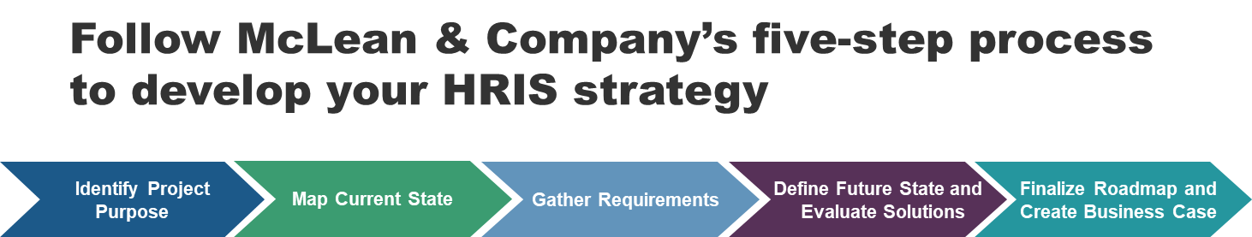

Get to Action
1. Identify project purpose | - Identify stakeholders and their roles and responsibilities.  - Clarify the purpose of your HRIS project.  - Align the organization goals, HR goals, and HRIS expectations.  - Determine the project scope and structure.  Deliverables:  - Case Studies: Drive Business Value With an HRIS Strategy  - Standard Project Charter Template  - HRIS Strategy Preparation Questionnaire  - Sample: HRIS Strategy and Roadmap for Douglas County
2. Map current state | - Map the current state of processes and technology.  - Develop an HRIS business environment model.  - Assess current process and technology maturity.  Deliverables:  - HRIS Strategy Documentation Tool  - HRIS Primer
3. Gather requirements | - Gather a list of high-level requirements from stakeholders and SMEs.  - Classify pain points.  - Prioritize HRIS functional areas.  Deliverables:  - Standard Focus Group Guide  - HRIS Strategy Preparation Questionnaire  - HRIS Strategy Documentation Tool
4. Define future state and evaluate solutions | - Define the future state.  - Select process and project metrics.  - Review different solution alternatives and select a course of action.  Deliverables:  - Process Mapping Guide  - HRIS Process Owner Assignment Guide
5. Finalize the roadmap and create the business case | - Build an HRIS roadmap.  - Create a risk management plan.  - Finalize a business case to present to stakeholders.  Deliverables:  - Project Roadmap Tool  - HRIS Readiness Assessment Checklist Template  - Standard Project Charter Template  - Develop a Sound Business Case to Accelerate Buy-In Templates  - Workshop: Drive Business Value With an HRIS Strategy
__________________________________________________

For acceptable use of this template, refer to McLean & Company's Terms of Use. These documents are intended to supply general information only, not specific professional, personal, legal, or accounting advice, and are not intended to be used as a substitute for any kind of professional advice. Use this document either in whole or in part as a basis and guide for document creation. To customize this document with corporate marks and titles, simply replace the McLean & Company information in the Header and Footer fields of this document.

